Question 1

**Report title: The role of System Analysis and Design on the Airport Customer Relation Management System.**

**Introduction:**

Systems Analysis and Design(SAND) is the process of understanding, defining, and designing efficient and effective information systems that satisfy the needs of a specific business. By using System analysis and design in the Airport Customer Relations Management System, we will be able analyse the airport operations, customer interactions, and technological requirements to design a suitable solution that will satisfy the needs of the airport system.( Mukherjee, 2023)

**Importance of conducting System Analysis and Design properly:**

* Conducting the process of analysing and designing a solution properly is crucial in ensuring that the business operates efficiently and strategically. (anon, nd)
* Properly conducting this process also helps the designers to understand the needs of the user to ensure that the airport maintains good customer relations by making it more user friendly and diverse. (anon, nd)
* SAND will allow the airport to operate more cost effectively by allocating resources strategically, minimizing redundancy, and effectively using existing technology which minimizes business costs.(Mukherjee, 2023)
* System analysis identifies the short comings in the current airport processes which allows the designer to solve the inefficiencies which will improve operational efficiency and improve service delivery. (Mukherjee, 2023)
* SAND will allow the airport system to be more scalable and adaptable to the evolving and growing business which will allow the further growth of the airport as well as make it more adaptable to new technologies. (anon, nd)

**System Analysis activities:**

* **Understanding the needs of the user –** system analysts will need to gather information from multiple sources such as airport management, airport staff, passengers, etc, to fully understand the needs and expectations of the user. This can be done by using surveys or interviews. (Feronika, 2018)
* **Analysing feasibility –** analysts will study the available resources of the airport such as technology, infrastructure, and budget to design an effective business solution.(Feronika, 2018)
* **Analyse business processes –** analysts will analyse the current business processes to identify opportunities and areas for improvement to mitigate inefficiencies and unnecessary expenditure of resources. (Bydrec, nd)
* **Analysing stakeholders –** understanding how the stakeholders will be affected by the airport customer relation management system is key as it will allow designers to understand how to design a system which aligns with the needs and expectations of the stakeholders. (Bydrec, nd)
* **Analysing data –** analysing the pre-existing data will aid the design of data models, database schema, and data integration requirements for the airport customer relation management system(Bydrec, nd)

**System Design activities:**

* **Architectural Design –** Designers will need to design a scalable architecture to accommodate future growth(anon, 2022)
* **Interface Design –** designers will need to design a user-friendly interface which makes it easier for users to access flight information, airport navigation, and medical attention. (anon, 2022)
* **Database Design –** designers will design a database schema to store data such as flight information which will be stored as entities. (anon, 2022)
* **Integration Design –** designers will plan out how they will integrate their airport customer relation management system with the pre-existing systems to ensure efficiency.(anon, nd)
* **Security Design –** Designers will need to implement security features to protect the user information. This will ensure the integrity of the airport customer relation management system.(anon, nd)

**Motivation for Iterative Approach:**

By adopting an iterative approach to developing the airport customer relation management system, the system will benefit by:

* **Debugging**- an iterative approach helps developers identify inconsistencies and issues early in the development process which makes it easier to debug. (Roper, 2021)
* **Flexibility**- the iterative approach allows the system to continuously evolve and adjust according to the needs of the user.(Arrotek, 2024)
* **Risk Mitigation**- the iterative approach breaks down processes into smaller sub-processes which makes it more manageable and easier to identify risks.(Roper, 2021)
* **Continuous improvement**- the iterative approach has a continuous nature which allows the software to evolve indefinitely keeping up with the emerging user trends.(Arrotek, 2024)

**Conclusion and Motivation for Selection:**

In conclusion, system analysis and design will play a major role in the development of the airport customer relation management system by analysing the needs of the user, gathering the necessary information, and designing a system based on the research done by system analysts. This will ensure that the designers understand the needs of the user, the availability of resources, and the affected stakeholders which will allows them to create a system which satisfies the needs of all parties involved. With my meticulous attention to detail and commitment to this project, I will ensure that the airport customer relation management system will be equipped with the latest technology which will not only meet the current requirements of the airport but also the future requirements as the airport expands. This will ensure that the airport customer relation management system remains relevant and adaptable to all sorts of challenges and trends which makes me the ideal developer for this project.

Question 2

1. **Airport manager-** the airport manager will define the goals and set the expectations for the project. They are the decision makers.(anon, 2023)
2. **Airport staff-** the airport staff such as customer service and security personal will be using the airport customer relation management system on a daily basis. These stakeholders are key to providing first hand insights into the system as they will identify weaknesses and opportunities within the system.
3. **Passengers-** passengers will provide information on their user experience, which services they use the most, and areas for improvement. This information can be obtained through surveys which will be used to improve the user experience of the system.
4. **Airport medical team-** the medical team will provide data on the resources needed to help patients timeously and the most common type of medical attention needed.
5. **Airport IT team-** the IT team will contribute by providing their skill to define requirements for the new system which meets the user’s expectations. They will work with system analysts to design a suitable system for the airport customer relation management system

Question 3

3.1

User checks flight information:

**Use case** -view flight information

User checks services available at airport:

**Use case** – view available services

User navigates through airport:

**Use case** – navigate to airport lounge

User requests medical attention:

**Use case** – request medical assistance

3.2

**Use Case Name:** View Flight Information

**Triggering Event:** User selects the "View Flight Information" option from the airport customer relations management system

**Description:** This use case allows user to view flight information such as departure time, boarding time, or flight number.

**Actors:**

Passengers – they use the system

Airport staff- they assist the passengers with the system.

**Related Use Cases:** None

**Stakeholders:**

* Airport Management – ensures passenger to have a positive user experience and gain access to their information.
* Passengers- requires correct and up to date information
* Airport Staff- provides assistance to the passenger if needed.

**Preconditions:**

* The user must be logged into the system
* The system is online

**Post Conditions:**

* The user has acquired their desired information

**Flow of Activities:**

1. **The request is triggered:** The user selects the "View Flight Information" option
2. **Data retrieval:** The data is retrieved from the system database.
3. **Display information:** The system displays the users flight information that it retrieved from the system database.
4. **User action:** Once the user has accessed their information, they can choose to log off.

**Exception Conditions:**

* If there is no flight information on the database, the system will display an error message and will be asked to try again or call for assistance. (anon, nd)

Question 4

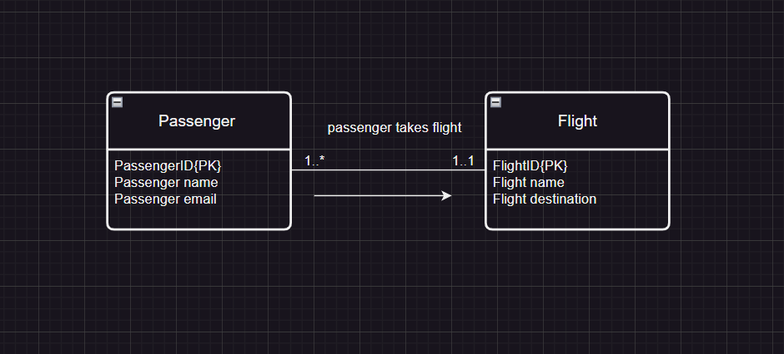

Bibliography

(No date a) *Developing a use case: How to and why it is important | indeed.com*. Available at: <https://www.indeed.com/career-advice/career-development/developing-use-case> (Accessed: 09 April 2024).

(No date b) *What is System Analysis and Design? (plus benefits) | indeed.com*. Available at: <https://www.indeed.com/career-advice/career-development/what-is-system-analysis-and-design> (Accessed: 09 April 2024).

Airline Management                                                                                                          Airline Management                                                                                                                (2023) *How can you identify the stakeholders of a Change Management Project in an airline?*, *How to Identify Stakeholders of Airline Change Management*. Available at: <https://www.linkedin.com/advice/3/how-can-you-identify-stakeholders-change-management-yy7cf#:~:text=Similarly%2C%20passengers%2C%20travel%20agents%2C,airlines%20are%20all%20potential%20stakeholders>. (Accessed: 09 April 2024).

Arrotek (2024) *Benefits of an iterative design process - ARROTEK: Medical device innovation*, *Arrotek*. Available at: <https://arrotek.com/benefits-of-an-iterative-design-process/#:~:text=Benefits%20of%20Using%20Iterative%20Design&text=Highlights%20and%20helps%20to%20resolve,functionality%2C%20usability%2C%20and%20reliability%20objectives> (Accessed: 09 April 2024).

Bydrec, I. (no date) *System development life cycle phases : A detailed list*, *System Development Life Cycle Phases : A Detailed List*. Available at: <https://blog.bydrec.com/a-detailed-list-of-the-system-development-life-cycle-phases#:~:text=It%20involves%20the%20activities%20of,meets%20or%20exceeds%20client%20expectations>. (Accessed: 09 April 2024).

Feronika, N. (2018) *Systems analysis activities*, *School of Information Systems*. Available at: <https://sis.binus.ac.id/2018/01/15/systems-analysis-activities/> (Accessed: 09 April 2024).

Mukherjee, S. (2023) *What is information system? definition, examples, & facts*, *Emeritus India*. Available at: <https://emeritus.org/in/learn/information-system/#:~:text=Information%20system%20helps%20a%20business,allows%20employees%20to%20communicate%20effectively>. (Accessed: 09 April 2024).

Roper, K. (2021) *Importance of system analysis in software development*, *LinkedIn*. Available at: <https://www.linkedin.com/pulse/importance-system-analysis-software-development-kimone-roper> (Accessed: 09 April 2024).

*System analysis & design - system design* (no date) *Tutorialspoint*. Available at: <https://www.tutorialspoint.com/system_analysis_and_design/system_design.htm> (Accessed: 09 April 2024).

*System design: What is it and why it is important* (2022) *SegWitz*. Available at: <https://segwitz.com/what-is-system-design-and-why-it-is-necessary/#:~:text=System%20design%20is%20the%20process,Need%20to%20Know%20About%20Chatbots> (Accessed: 09 April 2024).